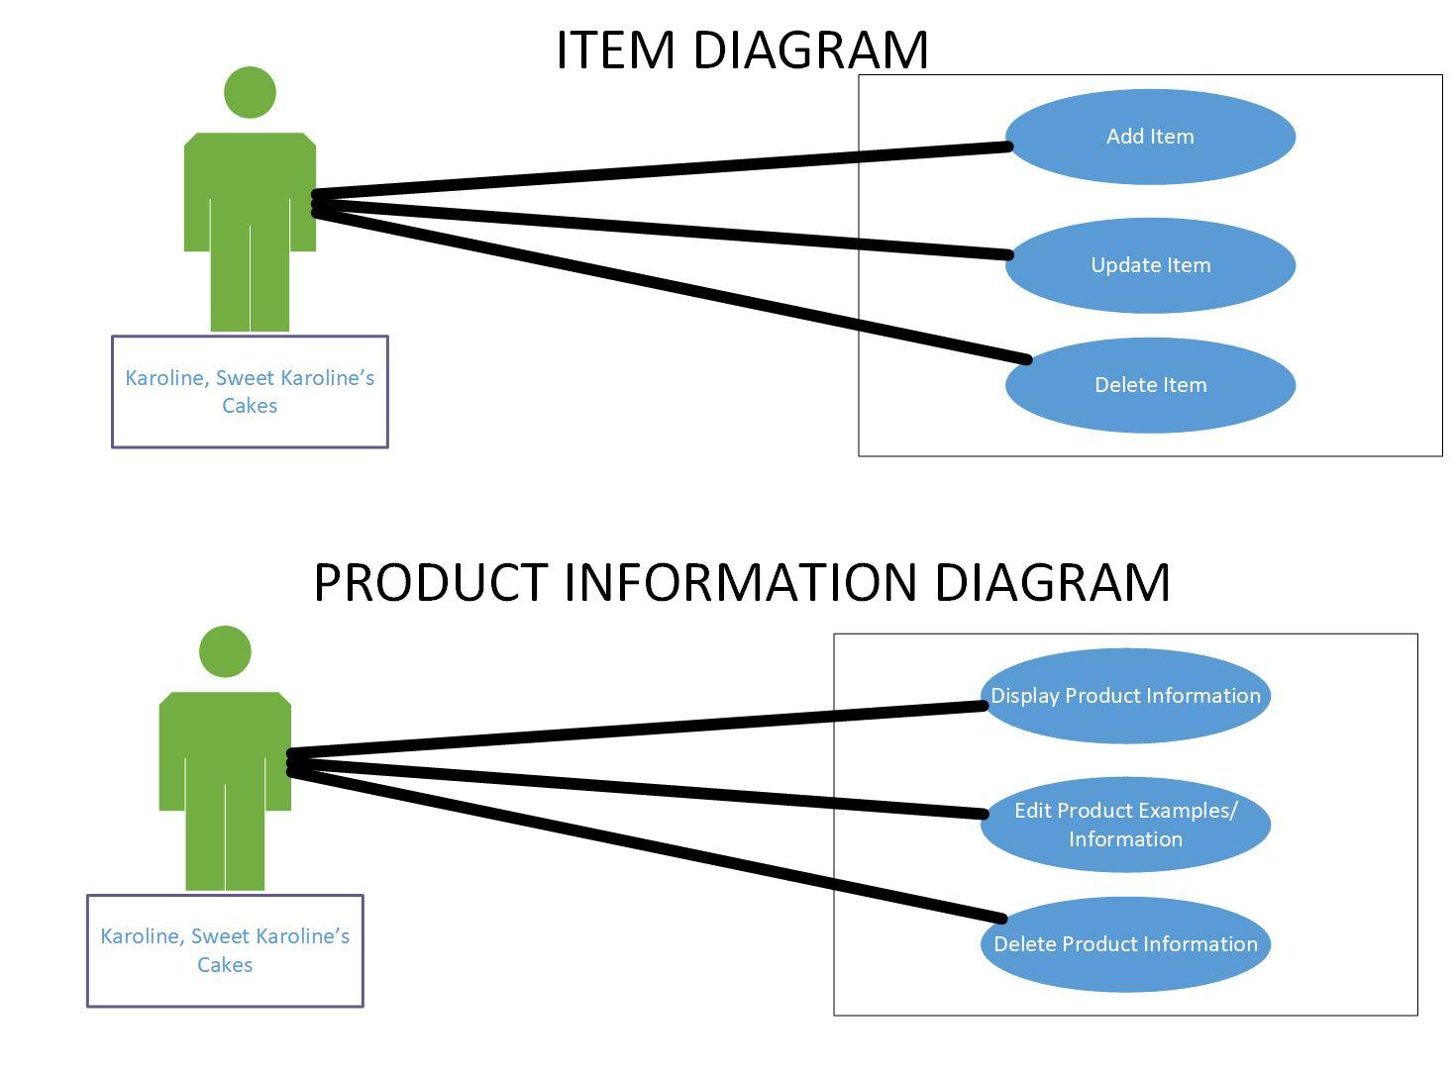

The above use case diagrams show the actor Karoline, interacting with the system.  It shows that Karoline is able to add items, update items, and delete items. It also shows the Karoline can display product information, edit product information, and delete product information.

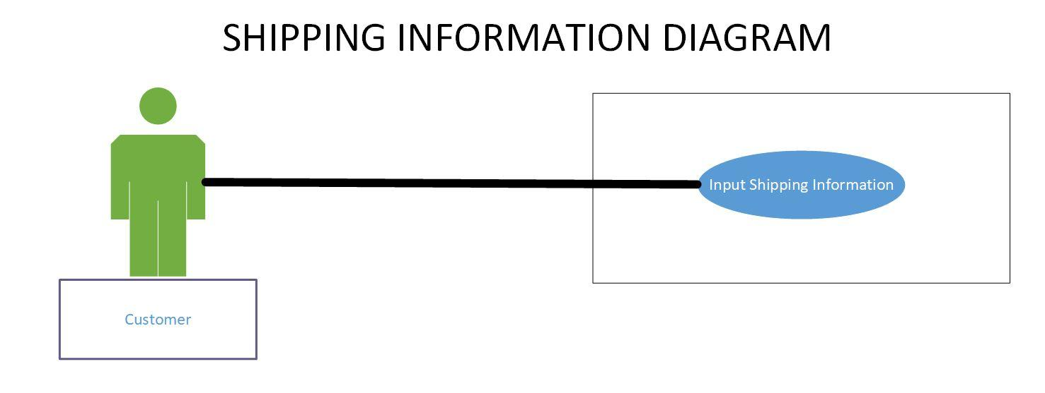

The above use case diagrams show the actor, the customer, interacting with the system.  It shows that the customer is able/responsible for inputting their own shipping information. This will take place after an order has been created.